|  |  |
| --- | --- |
| **Artificial Intelligence healthcare** | Submitted By:-  Rineesh  Shadhin  Muhammed Zameel  Akil das  Athulya |

**Artificial Intelligence healthcare**

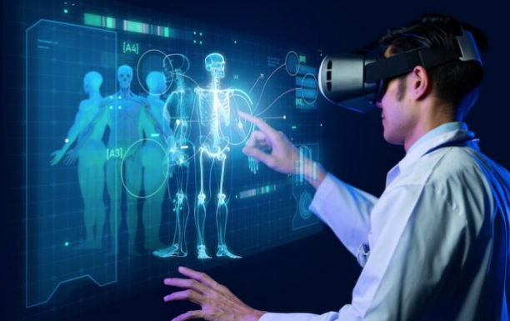Artificial Intelligence (AI) has rapidly evolved over the past decade, bringing transformative change across various sectors, with healthcare being one of the most promising fields for AI applications. From diagnostics and personalized treatment plans to operational efficiencies and drug discovery, AI technologies have shown significant potential in improving patient outcomes, optimizing healthcare delivery, and reducing costs. This paper explores several applications of AI in healthcare, highlighting how AI is enhancing patient care, diagnostics, and operational efficiency.

**AI in Diagnostics**

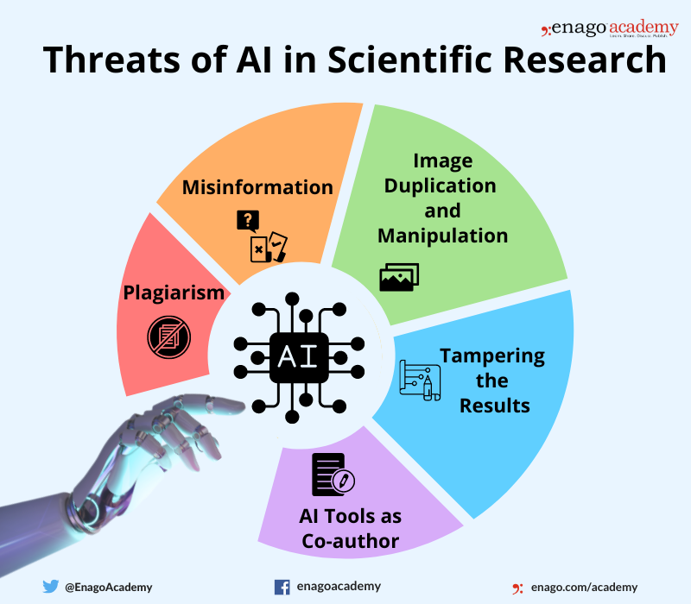One of the most impactful applications of AI in healthcare is in diagnostic imaging. AI algorithms, particularly deep learning, have demonstrated their ability to analyse medical images—such as X-rays, CT scans, and MRIs—with remarkable accuracy. In radiology, AI tools can detect abnormalities like tumors or fractures that may be overlooked by human eyes. For instance, a study by Esteva et al. (2017) revealed that deep learning models could match or even surpass dermatologists in diagnosing skin cancer from images. Similarly, AI models have been used in detecting lung cancer, identifying heart conditions, and even diagnosing rare diseases from medical scans (Litjens et al., 2017).

**Personalized Treatment and Predictive Analytics**

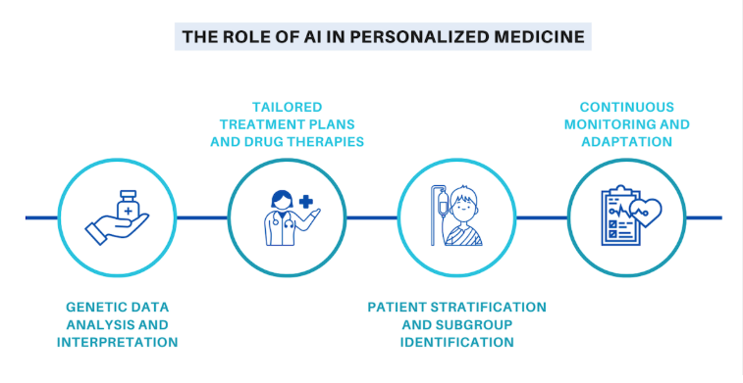AI also plays a crucial role in the development of personalized medicine. By analysing vast amounts of patient data, including genetic information, lifestyle factors, and medical history, AI systems can generate individualized treatment plans that are more likely to be effective. AI-driven predictive analytics can forecast disease progression and suggest tailored interventions. For example, in oncology, AI models can predict how a patient will respond to specific chemotherapy regimens based on their genetic profile and tumor characteristics (Kourou et al., 2015). This allows healthcare providers to move away from a one-size-fits-all approach and deliver more targeted therapies.

**AI in Drug Discovery**

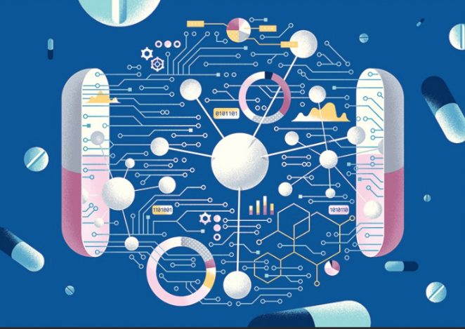AI is also transforming the drug discovery process. Traditionally, drug discovery has been a time-consuming and costly endeavour, involving trial and error and long periods of clinical testing. AI technologies, particularly machine learning, can sift through enormous datasets, including molecular structures and clinical trial outcomes, to identify promising drug candidates more quickly and accurately. For instance, AI platforms have been used to discover new antibiotics and antiviral drugs, as well as identify existing drugs that could be repurposed for new uses (Zhavoronkov et al., 2019). AI algorithms can predict how different compounds will interact with biological targets, speeding up the drug development pipeline and potentially bringing life-saving medications to market faster.

**Operational Efficiency and Administrative Tasks**

AI has the potential to streamline many administrative tasks in healthcare, leading to more efficient operations. Natural language processing (NLP) systems can automate the extraction of information from clinical notes and electronic health records (EHRs), allowing healthcare providers to spend more time with patients and less time on paperwork. AI-powered chatbots are also being used for patient triage, appointment scheduling, and answering basic medical inquiries. Moreover, predictive analytics can optimize hospital operations, such as staffing levels, bed occupancy, and supply chain management, ensuring that healthcare facilities run more efficiently and are better equipped to handle patient demands (Rajkomar et al., 2019).

**Conclusion**

The applications of AI in healthcare are vast and growing, offering transformative potential in diagnostics, treatment personalization, drug discovery, and operational efficiency. While there are challenges, such as data privacy concerns and the need for healthcare professionals to adapt to new technologies, the benefits of AI in healthcare are undeniable. As AI continues to evolve, it is likely that its role in healthcare will expand, leading to improved patient outcomes, reduced costs, and more efficient healthcare systems worldwide.

**References**

Esteva, A., Kuprel, B., Novoa, R. A., Ko, J., Swetter, S. M., Blau, H. M., & Thrun, S. (2017). Dermatologist-level classification of skin cancer with deep neural networks. *Nature*, 542(7639), 115-118. https://doi.org/10.1038/nature21056

Kourou, K., Exarchos, T. P., Karamouzis, M. V., & Papaloukas, C. (2015). Machine learning applications in cancer prognosis and prediction. *Computational and Structural Biotechnology Journal*, 13, 8-17. https://doi.org/10.1016/j.csbj.2014.11.005

Litjens, G., Kooi, T., Bejnordi, B. E., Setio, A. A. A., Ciompi, F., Ghafoorian, M., van der Laak, J. A. W. M., van Ginneken, B., & Sana, R. (2017). A survey on deep learning in medical image analysis. *Medical Image Analysis*, 42, 60-88. https://doi.org/10.1016/j.media.2017.07.005

Rajkomar, A., Dean, J., & Kohane, I. (2019). Machine learning in medicine. *New England Journal of Medicine*, 380(14), 1347-1358. https://doi.org/10.1056/NEJMra1814259

Zhavoronkov, A., Aliper, A., Artemov, A., Zhebrak, A., & Polykovskiy, D. (2019). Deep learning enables rapid identification of potent DDR1 kinase inhibitors. *Nature Biotechnology*, 37(10), 1038-1040. <https://doi.org/10.1038/s41587-019-021>